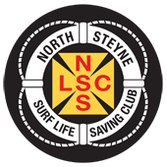
North Steyne SLSC Inc.
Nomination Form
LIFE MEMBERSHIP

NAME OF MEMBER BEING NOMINATED: DATE:________________________

FOR LIFE MEMBERSHIP NOMINATIONS ONLY: [two steps required]
- Nomination by five (5) members, each with a minimum 10 years’ service:
Nominator | Signature [or email attached] | Length of Service

- Endorsement by two (2) Life Members of the club:
Endorser | Signature [or email attached]

Note that all decisions of the Life Membership & Honours Panel are final

